CONFIGURATION OF SEND MAIL SERVER
To install the package #yum install sendmail* m4* -y
Main configuration files are access, sendmail.mc and send mail.cf.
Open /etc/mail/sendmail.mc for editing #vi /etc/mail/sendmail.mc
O/P To comment a line in sendmail.mc, just put dnl at start of line.
dnl DAEMON_OPTIONS(`Port=smtp,Addr=127.0.0.1, Name=MTA')dnl
m4 ia a macro processor to compile the Sendmail configuration files. m4 is stream-based, that is, it doesn’t understand about lines
Recompile send mail configuration #m4 /etc/mail/sendmail.mc > /etc/mail/sendmail.cf
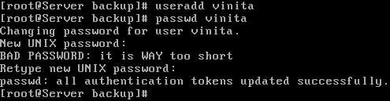
To restart sendmail service #service sendmail restart

Testing of sendmail server Now create one user on each system vinita on server
And nikita on client system
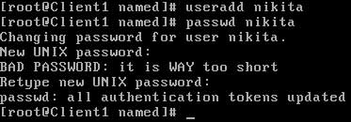
Now send mail from user vinita to nikita and from nikita to user vinita and also check each others mail by mail command
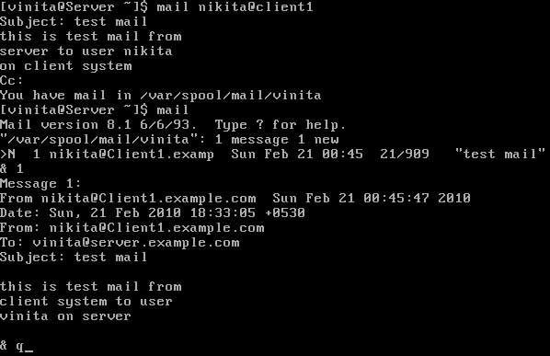
Use full user name to send mail. For example to send mail to nikita use nikita@client1
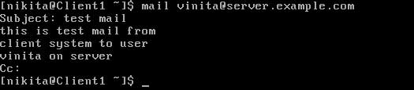
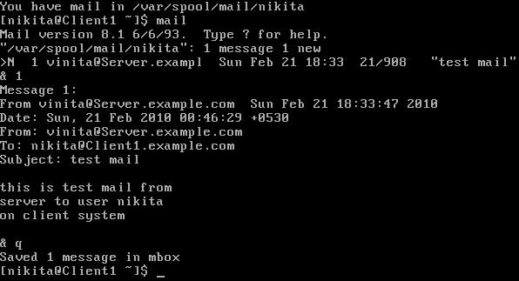

How to Send Email via SMTP Server from Linux Command Line (with SSMTP)

Step 1: Install SSMTP Server #yum install ssmtp * -y

Step 2: Configure SSMTP #vim /etc/ssmtp/ssmtp.conf
OUT PUT: Change following values in configuration file
mailhub=smtp.gmail.com:587 mailhub:you smtp server host/ip with port
UseSTARTTLS = YES UseSTARTTLS:Set it Yes if SMTP server uses TLS else No. AuthUser =myemail@gmail.com AuthUser:Use Gmail ID here
AuthPass = xxxxxx AuthPass:Use Gmail ID’s password
TLS_CA-File=/etc/pki/tls/certs/ca_bundle.crt TLS_CA_File:This may required some time, If you face issue like “send-mail: Cannot open smtp.gmail.com:587″

Step 3: Send Test Email #ssmtp user@domain.com (ex:gmail.com)
OUTPUT: subject:this is subject line
email content line:1
email content line:2
email content line:3 (ctrl+d)

Step 4: Setup SSMTP as Default #alternatives --config mta
OUT PUT There are 2 programs which provies 'mta' .
Selection command
--------------------------------------------------------------------------------------------
1. /usr/sbin/sendmail.ssmtp
* + 2. /usr/sbin/sendmail.sendmil
Enter to keep the current selection[+] 1 or type selection number : 1
Verify the changes by #sendmail -V

